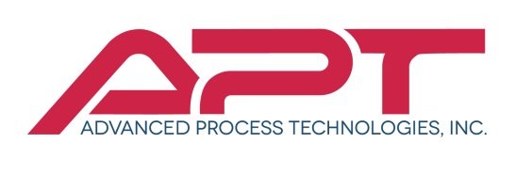
Stainless Steel Welder – 1st Shift

We are looking for a skilled Welder with experience in both TIG and Wire Feed processes to fabricate stainless steel. You will operate appropriate equipment to put together equipment for the food and dairy industry with a great deal of precision. Your job is important as it provides the foundation for strong infrastructure. A welder must be competent in using potentially dangerous equipment following all safety precautions. The ideal candidate will have a steady hand and great attention to detail.
Responsibilities
- Read blueprints and drawings and take or read measurements to plan layout and procedures
- Determine the appropriate welding equipment or method based on requirements
- Set up components for welding according to specifications
- Operate grinders to prepare the parts that must be welded
- Align components using calipers, rulers etc. and clamp pieces
- Maintain equipment in a condition that does not compromise safety

Skills
- Proven experience as welder
- Experience using a variety of welding equipment and procedures (TIG, MIG.)
- Experience in using electrical or manual tools
- Ability to read and interpret technical documents and drawings
- Knowledge of relative safety standards and willingness to use protective clothing
- Deftness and attention to detail
- Professional Certification (e.g. an AWS welding certificate) will be a plus

Our employment positions at APT will provide opportunity to demonstrate your expertise and position yourself for career advancement with a growing and innovative company. Since 2000, Advanced Process Technologies has provided solid, stable careers for many good people. As market leaders, we have had tremendous growth through the years, and are poised for even greater growth.

APT is 100% Employee Owned with a wide array of benefits that include: Employee Stock Ownership Plan, 401K, HSA savings, medical, life insurance and paid time off. Our company stands out because of our commitment to our employees while providing an industry leading wage.

Mail, fax or email resume to: APT / Attn: HR
PO Box 939 | Cokato, MN 55321 | Email: apt@apt-inc.com

